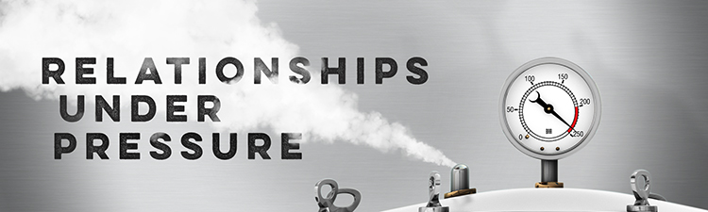

Bop It

John 8:36-44(NIV): So, if the Son sets you free, you will be ____________. ³⁷ I know that you are Abraham’s descendants. Yet you are looking for a way to kill me, because you have _______________________________. ³⁸ I am telling you what I have seen in the Father’s presence, and you are doing what you have heard from your father. ³⁹ “Abraham is our father,” they answered. “If you were Abraham’s children,” said Jesus, “then you would ___________________________. ⁴⁰ As it is, you are looking for a way ______________ a man who has told you the truth that I heard from God.Abraham did not do such things. ⁴¹ You are doing the works of your own father.” “We are not illegitimate children,” they protested. “The only Father we have is God himself.” ⁴² Jesus said to them, “____________________________, for I have come here from God. I have not come on my own; God sent me. ⁴³ Why is my language not clear to you? Because you are unable to hear what I say. ⁴⁴ You belong to your father, the devil, and you want to carry out your father’s desires."

Every person on the planet is your _______________

Ephesians 6:12(NIV)P "For our struggle is not against flesh and blood, but against the rulers, against the authorities, against the powers of this dark world and against the spiritual forces of evil..."

Top Two Habits of Happy Couples
- Everyone has _____________
- We are a ______________
"Help me understand what it's like to be you? Raleigh Washington
Numbers 6:23-26: ‘This is the way you shall bless the children of Israel. Say to them:
²⁴ “The Lord bless you and keep you; ²⁵ The Lord make His face shine upon you, And be gracious to you; ²⁶ The Lord [e]lift up His countenance upon you, And give you peace.” ’

All scriptures referenced are from the New International Version (NIV) translation of the Bible unless otherwise indicated.

